Technology
Year (s) 3/4 | Situation/Big Question: What happens in the process “from moo to you”? |  | Duration 6 weeks
Key Competencies: (Highlight one focus key competency) |  | Values (Highlight one focus value)
Thinking; Using Language, symbols and text, Managing self; Relating to others; Participating and Contributing |  | Excellence; Innovation; Inquiry and Curiosity; Equity; Community and Participation; Ecological sustainability; Integrity; Respect

Level: 1 | Achievement Objectives – Technological Practice
Planning for Practice (PP)
Describe the outcome they are developing and identify the attributes it should have, taking account of the need or opportunity and the resources available.
Brief Development (BD)
Outline a general plan to support the development of an outcome, identifying appropriate steps and resources.
Outcome development and evaluation (ODE)
Investigate a context to communicate potential outcomes. Evaluate these against attributes; select and develop an outcome in keeping with the identified attributes.
Achievement Objectives – Technological Knowledge

Technological modelling (TM)
Understand that functional models are used to represent reality and test design concepts and that prototypes are used to test Technological Outcomes
Technological products (TP)
Understand that technological products are made from materials that have performance properties.
Technological systems (TS)
Understand that technological systems have inputs, controlled transformations, and outputs.

Achievement Objectives – Nature of Technology

Characteristics of technology (CT)
Understand that technology is purposeful intervention through design
Characteristics of technological outcomes (CTO) Understand that Technological Outcomes are products or systems developed by people and have a physical nature and a functional nature

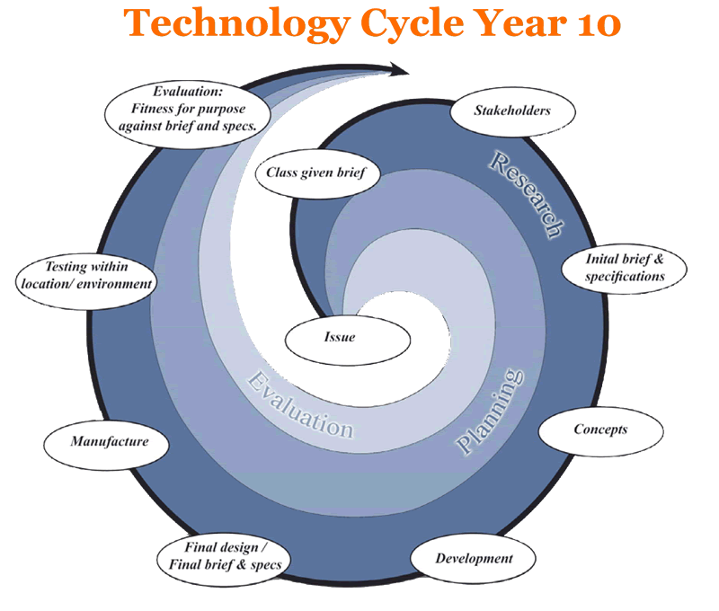 | Teaching and Learning Experiences  (bullet point list of experiences) | Learning Outcomes  (Assessment Focus)
 | Session one  What do we know and want to know about cows, dairy farms and dairy products? Record childrens responses in Big Book.  Where does milk come from? What products do you think have milk in them? What would you like to find out about dairy farms? What do we know about cows?  Introduce Rosie - video and show her blog  http://www.rosiesworld.co.nz/about-rosie/video-cowbassador  Session two  What is a breed? Discuss what breeds of cows the children already know. Watch the video about Rosies family and record answers to question sheet. Watch twice and pause video to allow children to record their answers  http://www.rosiesworld.co.nz/rosies-farm/video-family-tree-cowcam  Session three  A cows digestive system - watch video about a cows digestive systesm. Children draw and label the system on a cow picture. What system is this? Refer back to charty from term on with social, natural, oraganisational and technological systems. Discuss the inputs, transformations and outputs of this system.  http://www.rosiesworld.co.nz/rosies-farm/video-from-grass-to-glass  Session four  Clay cows – look at photos of cow parade http://auckland.cowparade.net/cow/gallery childre are going to make their own clay cow sculptures. These will be painted and displayed in class. Particular focus on the physical features of a cow. (3-4 art sessions to create)  Session five  Farm systems – read books and watch video of the process of milking cows on the farm. Particualar focus on the systems and technology being used. Can children identify the inputs, transformations and outputs? Children sort out a pictorial diagram of the steps in the process.  http://www.rosiesworld.co.nz/about-milk/video-about-milk  Session six  Ask an expert – email our local dairy farmer that we are going to visit and ask our “burning questions” these may be answered via email or when we do the visit.  Session seven  Factory systems – research and learn about what happens in the factory. Children will split into groups and find out more about milk; pasturization, homoginisation and separation.  http://www.rosiesworld.co.nz/about-milk/video-about-milk  Session eight  Robotics on the Farm – watch the movie about robotic dairy farms – is this what we will see when we go out? Pro’s and cons? What technology is involved? What is the system here?  http://www.rosiesworld.co.nz/rosies-farm/video-robotic-milking-farms-cowcam  Session nine  Dairy farm visit – visit a local dairy farm to see the milking process in action.  Session ten to twelve  Posters – children are going to present their research and understanding on a poster. This will include a diagram of the digestive system and a technological system. Facts about cows and a photo of their clay cow. It will also have some information about dairy products.  Session thirteen  Evaluation - children to write a report of their ideas of “from Moo to you” Write it as if the person reading doesn’t know anything about the dairy process. | TP  TK  • identify the components of a technological system and how they are connected  • identify the input/s and output/s of particular technological systems  • Identify that a system transforms an input to an output.  NoT  identify technological outcomes in a group of technological and non- technological objects and systems
Key Resources
Website – Rosies World http://www.rosiesworld.co.nz/
Books about Dairy Farms –

Thinking Strategy/Tool

E-Learning Tools
Websites, powerpoints, videos on Rosies World, email
Te Reo/Tikanga

Community Links
Visit to local dairy farm
Emailing a dairy farmer

